1-D Steady State Convection Diffusion with Porous Medium MATLAB Code:

% define variables

L=1; % length of rod

n=101; % number of grid points

dx=L/(n-1); % Grid spacing

x=linspace(0,L,n); % Grid points

density=1; % Density of material

u=1; % Velocity of particle

gamma=0.5; % coefficient

S=x.\*(x-1); % define the source term

% define the initial condition

phi=zeros(1,n);

phi=x.^2;

% define the matrix for the finite difference method

A=zeros(n,n);

A(1,1) = 1;

for i = 2:n-1

A(i,i-1) = -density\*u/dx - gamma/dx^2;

A(i,i) = 2\*gamma/dx^2;

A(i,i+1) = density\*u/dx + gamma/dx^2;

end

A(n,n)=1;

% solve for the steady state solution

phi=A\S';

% plot the graph

plot(phi,x);

xlabel('phi');

ylabel('x');

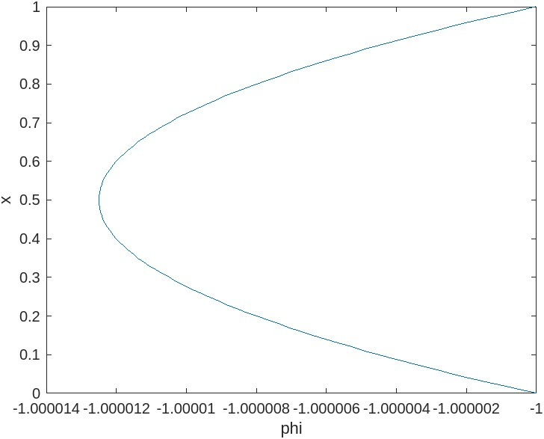

1-D Steady State Convection Diffusion without Porous Medium MATLAB Code:

% define variables

L=1; % length of rod

n=51; % number of grid points

dx=L/(n-1); % Grid spacing

x=linspace(0,L,n); % Grid points

density=1; % Density of material

u=1; % Velocity of particle

gamma=0.5; % coefficient

S=x.\*(x-1); % define the source term

% define the initial condition

phi=zeros(1,n);

phi=x.^2;

% define the matrix for the finite difference method

A=zeros(n,n);

A(1,1) = 1;

for i = 2:n-1

A(i,i-1) = -density\*u/dx - gamma/dx^2;

A(i,i) = 2\*gamma/dx^2;

A(i,i+1) = density\*u/dx + gamma/dx^2;

end

A(n,n)=1;

% solve for the steady state solution

phi=A\S';

% plot the graph

plot(phi,x);

xlabel('phi');

ylabel('x');

